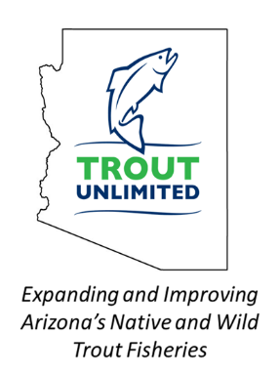
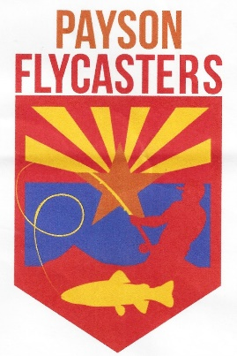
Payson Flycasters
& TU Chapter 530 Newsletter

Issue 27 www.paysonflycasters.org www.gilatrout.org November15, 2020

Welcome to the November, 2020 issue of our newsletter!

Trout are back in Green Valley Lakes! Gilas still biting in the East Verde! Tigers are coming toward the shore in the Rim lakes! Silver Creek is open and members are catching there, not just fishing

But the news continues… Flycaster’s has an almost new Fishcat float tube for sale $699 on line—but $400 is your price—donated by Tom with all proceeds to the hatchery—get it before we put it on Craig’s list for $450.
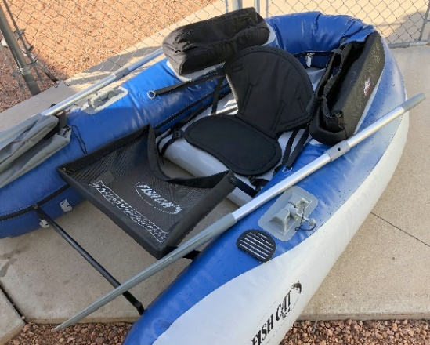
November program will feature a variety of trip reports with an emphasis on trip opportunities provided by members. Get an early start on planning your 2021 trips now!

By the way, pin, patch and raffle ticket sales have generated over $1,600 for the hatchery with more to come. We continue to get orders off our website and income from the float tube, so….

Club leadership will send a $2,000 check to the hatchery in the next week. Thank you everyone! A huge effort.

Fly Casting Practice & Games Were Well Attended on October 31
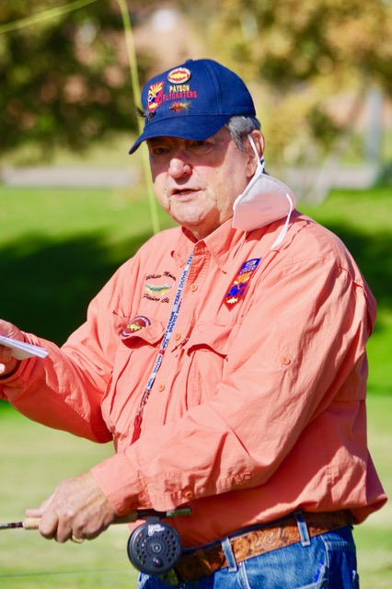
A Fun Time Casting and Getting to See Each Other
By Jim Strogen
Photos by Bob McMenemy

We have only been able to connect by way of Zoom meetings for the past few months. So it was great to see so many Club members in person (safely) at the Casting Games at Green Valley Lakes on October 31st. Thanks to Gary Bedsworth for organizing the morning of fun casting practice, and to Gary Volpe for making several of the stations for us to use at this event.
If you were not able to join us, there were ten stations. Many were challenging, but provided great practice to help us better encounter casting situations on the streams and lakes.

Here is Gary sharing
his considerable expertise.

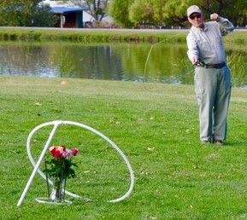
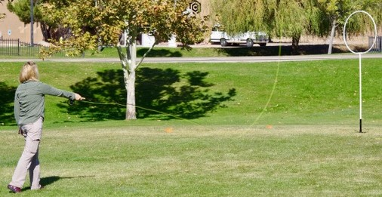
It was fun working through each station, but I had the most fun working with new fly fishers on particular casts both on the grass and along the north wall of the lake. A day like this helps drive home the point that practice makes you a better caster. This kind of event also is a perfect opportunity to provide some advice to help newer anglers get a bit more accuracy and distance in their casts.
Gary Bedsworth is planning to offer another practice day like this for one of our spring meetings. The thinking being that it will get us all geared up for the spring stockings and the start of the next trout season. I look forward to another day of fun casting with Club members.
Just a reminder though, there are plenty of fishing opportunities now and through the winter in Rim Country. The easiest place for us to continue to practice our casting is Green Valley Lake. There have been several trout stockings already this fall in all three lakes. The bluegills have remained cooperative as well.
I still keep having a great time catching fish on the East Verde River as the flows remain strong. It is a perfect time to Larry Hess (el Zorro) threads a cast.
explore the waters upstream or downstream from the stocking points as the Gilas have traveled quite a bit. The scenery is amazing, even if the catching has slowed.
I intend to give Upper Christopher, Horton, Tonto, the Upper East Verde and Canyon Creek another look with temperatures cooling down. This is a perfect time to get out and enjoy Rim Country fishing.

Canyon Creek Hatchery Gila Trout Program Donations
By Jim Strogen
Photos by Jim Strogen

Fly fishers can be a bit obsessive. We are known to tie flies that are almost too small to see on the end of our line in order to fool very selective fish. We are always trying to make the perfect cast that drops our fly lightly on the water to elicit that anticipated strike. But probably at the top of our list of obsessions is our fondness for trout.
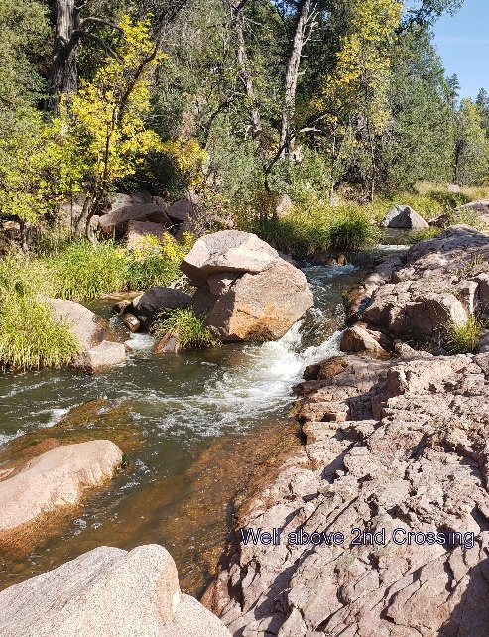
We have two great hatcheries in Rim Country with incredibly dedicated staff at both facilities. The Tonto Creek Hatchery accounts for 15 percent of the trout stocked in Arizona, while the Canyon Creek Hatchery produces about 20 percent of the trout in the state. As trout lovers, what we never would have imagined was the possibility that the East Verde River would become a stream designated for recreational stocking of Gila trout, one of the two native trout of Arizona. Because these fish are so beautiful and such a blast to catch, I suspect that the members of the Payson Flycasters’ Club/Gila Trout Chapter of Trout Unlimited (PFC/GTTU) probably spent most of our fishing time this summer on the East Verde River.
The fact that Gila trout are in the river is due to the vision of the Arizona Game and Fish Department (AZGFD), and the tremendous efforts by the Canyon Creek Hatchery (CCH) staff to raise these challenging native trout.
Unlike rainbow trout that have been raised in hatcheries for about a century, Gilas still retain quite a bit of their wildness in the hatchery setting. Even as fry and fingerlings, they panic when staff approach to feed them or clean their tanks. The CCH staff learned that to calm these fish down and get them to eat properly so that they would grow quickly, they had to treat them like wild fish. That meant that they had to devise ways to provide cover for the fish, as well as clean the tanks and feed them with minimal human contact. This may seem like a lot of trouble compared to the much more manageable rainbow trout; but to anglers that appreciate fish that act wild as soon as they are stocked, that is exactly the kind of fish we want to be raised in our hatcheries.
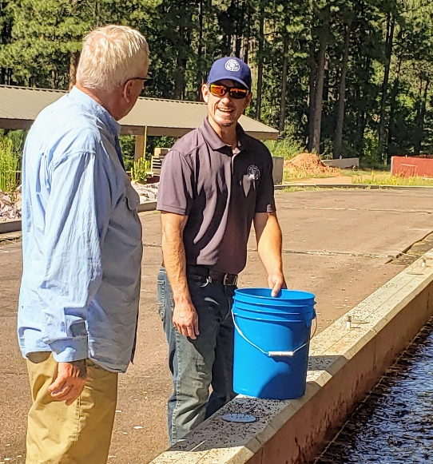
To add an even greater burden to the task, CCH has undertaken a remarkable goal that they will realize this spring when they will have successfully reared eggs from Gila trout broodstock for the first time that were raised on-site. These fish are being produced with the express purpose for recreational fishing. Once the program is up and running to the desired level, AZGFD hopes to stock other waters besides the East Verde River with these native Arizona trout.
Because these fish require specialized care and equipment, some additional purchases are needed that are outside of the allocated budget provided to all hatcheries.
The Mogollon Sporting Association led the way by providing a donation of $25,000 to Canyon Creek Hatchery to help them raise this native Rim Country trout. Recently, the PFC/GTTU, Old Pueblo Chapter of Trout Unlimited in Tucson, and two Valley fly fishing clubs -Arizona Flycasters’ Club, and Desert Flycasters Club- have donated over $5,000 for purchases that the hatchery needs for the Gila trout program.

Here’s Trevor Nelson, Hatchery Manager
refusing a request from Emperor Tom
who wanted to fish in the rearing tank.
So far, donations have been used for:

- Help with new plumbing for the Gila broodstock building.
- Special broodstock feed.
- Chainlink fencing and gate in front of broodstock building to keep out predators.
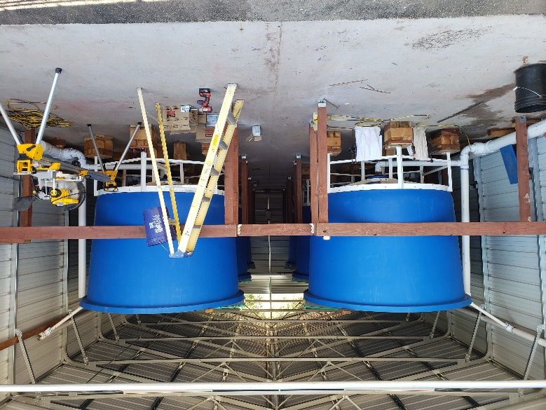
- Materials for decking around all six broodstock circular tanks to allow access for staff currently accessing each tank by a step ladder.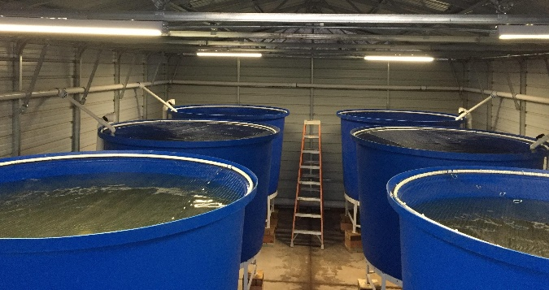

Above is a picture showing ladder only access.
To the right is the beginnings of a new decking
system that will be much safer and convenient. The new system building funds are from donations from our clubs and others.

- Skid mounted pressure pump to clean tanks, standpipes, screens, and culture tools.
- Metabolic assay testing to determine which eggs have the highest metabolic rate. Those with the highest metabolic rate are desired for broodstock as they will likely produce the fastest growing fish.
- Barrels of hydrogen peroxide for medical treatment of broodstock.
- Replacement components for automatic belt feeders to extend the life of existing feeders, including the mechanical clock mechanism that ensures feeding is spread over a 12-hour period.
- Automatic feeders for raceways, spare batteries, and a charger.

There are still some things that CCH staff need:

- Decking construction around the 6 broodstock circular tanks.
- Netting for raceways to protect Gila trout from predators and provide a visual barrier along with the overhead cover to reduce stress on Gila trout.
- Oxygen generators to increase the trout carrying capacity in the broodstock circular tanks.
- Separate sets of fish culture tools for each tank to avoid contamination between tanks.
- Improved incubation trays to provide an optimum rearing environment and increase survival rate from egg to fry.
- Additional metabolic rate testing and genetic testing to optimize future generations of broodstock.
- Formalin to treat eggs during the first stages of incubation.

With the state of Arizona budget severely impacted by Covid prevention and recovery costs, AZGFD is unable to access funds that have been targeted for hatchery renovations. This program, just getting off the ground, can’t afford any delays. Our organizations plan to continue to support the Gila trout program.
Do you love catching Gila trout, and appreciate the economic benefit that this trout brings to our community as anglers travel from across the state and country to catch a Gila trout? Check out www.paysonflycasters.org to find how the Club is helping the Gila trout program at Canyon Creek Hatchery.
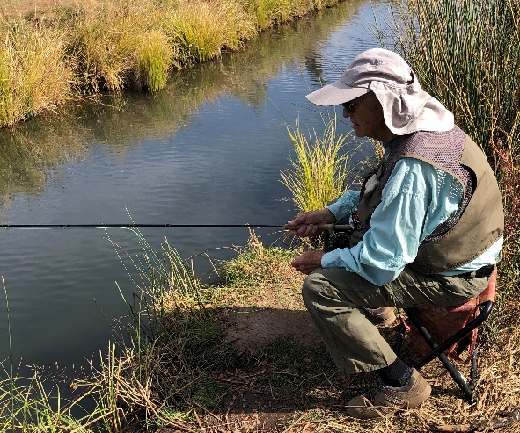
Silver Creek Outing By Tom Herman
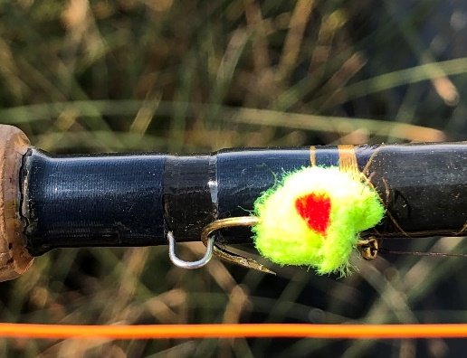
In mid-October a bunch of first timers went to Silver Creek outside of Show Low. Fishing was fun, except for the wind, catching not so much. Many trout were preoccupied in a spawning mood and seemed oblivious to our offerings. We went through a variety of bugs, and fish would swim up and look, but refuse to eat. Then, they went back to chasing each other. The new folks learned rigging techniques and were shown good spots to try for their next trip to Silver Creek.

Here’s Jerry Parr on Silver Creek

Here’s one of the “hot flies,” an egg pattern.

GTTU / PFC Conservation Activities By Joe Miller
Black River Forest Restoration in White Mtns: We submitted Comments on the proposed Black River Forest Restoration Project EA, as discussed in the October Newsletter, indicating our general agreement with the stream, riparian area and aquatics treatment approaches, and agreement that treatments on those resources should be integrated with vegetation treatments on surrounding areas before those vegetation treatments were begun. Also commented that sensitive water resources should be protected with appropriate fences and enclosures and also with adequate angling access points. Finally strongly supported USFS need to remove and keep Feral horses recently causing extensive damage to those water resources from the area.

East Verde River Restoration Project: Jim Strogen is working with Curt Gill of AZGFD and Jay Olsen of Tonto National Forest on timing of the last stage of the E Verde River Restoration Project near Washington Park. Work with Opportunity for Volunteer Efforts now likely up there in January.

Upper East Verde River Watershed Protection Project: Joe Miller continues working with Tonto National Forest and AZGFD to define and help launch a roughly 12,000 acre Watershed Protection Action Plan project area including Dude and Chase Creeks as an extension of the original very successful work on the EVR. Hoping for work next fall!

CC Cragin Watershed Protection Project: We’re continuing to work with the Mayor and Payson Town Staff, the Coconino National Forest, National Wild Turkey Federation, SRP, and several other agencies and organizations to achieve more of the already approved forest thinning around the Blue Ridge Reservoir, to thus help prevent high intensity fires, and so protect that major town water source which is also the source of the main water flow in the East Verde River. Lots more to report soon.

