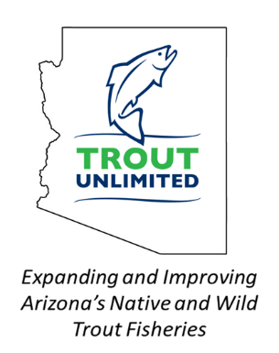
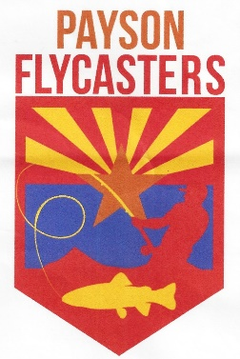
Payson Flycasters &
TU Chapter 530 Newsletter

Issue 11 www.paysonflycasters.org www.gilatrout.org August 15, 2019

Welcome to August—Monsoons! Yes!!!!
August 31 Meeting at Tiny’s 9 a.m!

It will be catchup time at the meeting. Quick reports (with more to come later in the Fall) from the Davis’ Idaho trip, Bedsworth/Davis/Hinkie Alaska, Herman in Colorado and more.
The main agenda discussion will be what the members want for programs for the next 12 months. Jim Strogen has completed capturing the data from the big survey most of you completed last Spring. During the August meeting, we hope to hear from you about specific activities and presentations that you would like to see us plan for the year to supplement what we already have penciled in. If you have something that you want to present at a meeting or an activity that you would like to lead, please let us know. Be sure and read Jim Strogen’s exclusive—to the club members only content later in OUR newsletter, his summary of the Survey Results and Joe Miller’s update on conservation related information.

Payson Flycasters’ Current Schedule

August 10: Teaching the 101 Class through Payson Parks and Rec. Jim Strogen
August 31: Regular Meeting at Tiny’s 9 am.
Sharing Summer fish stories and get member’s final inputs on the meeting programs for the balance of 19 and 2020 up through the Spring.
September 28: Regular Meeting Big trips show and tell.
October 1: Silver Creek Opens for catch and release
October 26: Regular Meeting—Jim Goughnour, AZGFD Commissioner for our area.
November 9: Project Healing Waters in Payson
November 30: Jack Houck, Orvis and local expert
Dec. 7: Christmas Party at Majestic Rim 5:30-9

The club needs a few more leaders to take just one responsibility to keep the programs rolling along:

- Silver Creek Coordinator—just someone that is willing to give out their email (we’ll make a small wallet card with this Coordinator and the others—see below) so that members can check in with someone specific about what is happening in their area of interest. The club usually heads up every other Wednesday after October 1. See below for other Wednesday trips.
- Wednesday Trip Coordinator—on the Wednesdays that the group is not going to Silver Creek, we can arrange trips to Willow Springs and other venues. Need a coordinator for the alternative Wednesday trips. Mostly again, to be a point of contact.
- Trout in the Classroom Coordinator—Dorothy Howell is the main contact, but she could really use a partner to work with her and secure volunteers for the Spring cleanup and the Fall installation. Just a few hours.
- Communications Coordinator—photography of events, help with the newsletter, getting meeting announcements into the Roundup. Social Media where we can.
- Project Healing Waters Coordinator—Tom Herman works with the Phoenix based groups, but helping organize the coffee/rolls/lunch at Green Valley for one day Spring and Fall would really help take the load off of the current officers.
The idea is just to be the coordinator for one of these activities, to be someone that knows what is happening and can be a contact resource for club members wanting to help or know what is happening.

We do need either a new Secretary. Dorothy Howell has held the position since the Mogollon Monster was in diapers, so in fairness, we owe her a break. She will chat with several candidates.

Here is Some Local Fishing Success

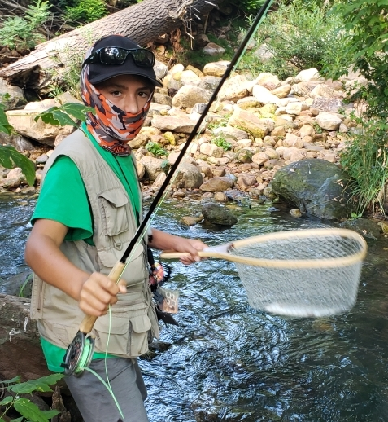

Who’s the Masked Man? Another Avenger? No its Owen Strogen caching fish number 16 on Canyon Creek on August 3. How many did Grandpa get?????

School Instruction Begins in August

The elementary and middle school fly fishing programs will begin in August. The fall classes are for kids that have already taken the Intro class. They will be learning how to tie flies and then give the fish a chance to critique their work every few weeks at GVL.
The Intro classes will start up in January. These classes are the ones that Club members help out with by providing flies for the kids (best flies are size 12-16 wet flies, bead-heads, zebra midges) and being a fishing coach for the fishing sessions of the class in April and May.
If you are in tying mode this summer, Jim would appreciate any flies that you can donate.
Besides TIC, ongoing adult intro to fly fishing classes, and kid after school programs, we look forward to our ongoing work with Project Healing Water Veterans, Silver Creek (and other) field trips, and the Wildlife Fair. The Christmas party and the Spring picnic at GVL are also in the plans for the upcoming year.

Dry Fly Dropper & a Wet Fly Trailer in Small Streams
(Exclusive Story from Jim Just for Members)

By Jim Strogen

In my July 30th Roundup article, I talked about my love for small stream fishing, some effective casting strategies, where to look for trout, and noted the importance of not spooking fish in this often shallow water setting. If you haven’t read that article in the Roundup yet, you can access it online at www.paysonroundup.com and then type my name in the search box.
An important fishing strategy for me in small streams is the way that I present my flies to the fish. I often use a dry fly dropper and a wet fly trailer combination. This particular rig works really well cast upstream, which is the more traditional way to fish a dry fly; and even better cast downstream.
Fishing a dry fly downstream is foreign to most fly fishers, but there are real advantages to this approach. I have used it on large streams for particularly finicky trout in difficult holding locations, but much more often in small streams.
When fishing a dry fly, one of the most important elements to control is drag on the line and fly as the current pushes and pulls at different rates that cause the fly to act unnaturally as it approaches the fish. This is often much more difficult to manage in an upstream cast than a downstream cast.
When casting upstream, you must also consider where the leader and tippet are in relation to the fish so that the fish isn’t spooked by the line before seeing the fly. Downstream dry fly fishing always puts the fly in front of the fish before the line.
The way that I use a dry fly on a small stream actually requires a trailer fly of some sort below the dry fly dropper. More often than not, I don’t just drift my dry fly downstream as I might in a larger stream. Instead, I provide movement to my dry fly as if it were a caddisfly or mayfly dropping eggs on the surface of the creek. To accomplish this action requires the weight that the trailer fly supplies.
My dropper rig using either a blood knot tag or a modified surgeon’s knot tag for the dry fly to hang down. That is a critical piece to the downstream approach, as it allows the dry fly to have a great deal of independent movement free of the weight of the trailer fly.
With a relatively short amount of fly line and a long fly rod (9 ft or longer) you can effectively dance the dry fly on the surface over targeted areas. The wet trailer during this movement of the dry fly acts like an emerging mayfly as it comes up to the surface, then drops back down as if trying to break through the surface film.
Variations in the weight and length of tippet behind the dropper to the trailer provide the angler with options to cover most situations encountered on the stream. The size and buoyancy of the dry fly are also important variable to consider.
In fast, deeper runs, I will usually use weighted trailer fly and a about a size 12 elk hair caddis dry dropper with about two feet of line between the two flies. In slower, more shallow water where a delicate approach is required to avoid spooking the fish I will use a smaller dry fly such as a Humpy (size 14) and either a small zebra midge (size 18) or an unweighted wet fly (size 16-18) with perhaps a foot or less of tippet between flies.
If it is a small creek, I am rarely in the water during this “cast”, and sometimes several feet up the bank. Often it is a bow and arrow cast or a modified roll cast to simply get the fly on the water that I can then manipulate in the current to the exact spot that I want to start providing action to my flies.
In a recent trip to Canyon Creek, I caught about 95% of my trout with this downstream rig imitating an egg laying caddis and an emerging mayfly vs. the traditional upstream dry fly approach. Sometimes it is the dry fly that gets slammed, sometimes it is the wet fly; in any case, the combination is extremely effective. It is definitely a trick worth adding to your fishing tool box.

New Fishing Guide from the Roundup
Jim Strogen has been instrumental in helping the Roundup create this publication. Thanks also to Joe Miller for the conservation information.
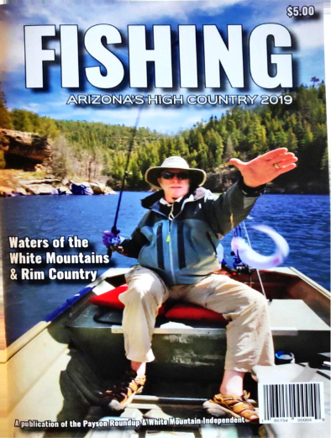
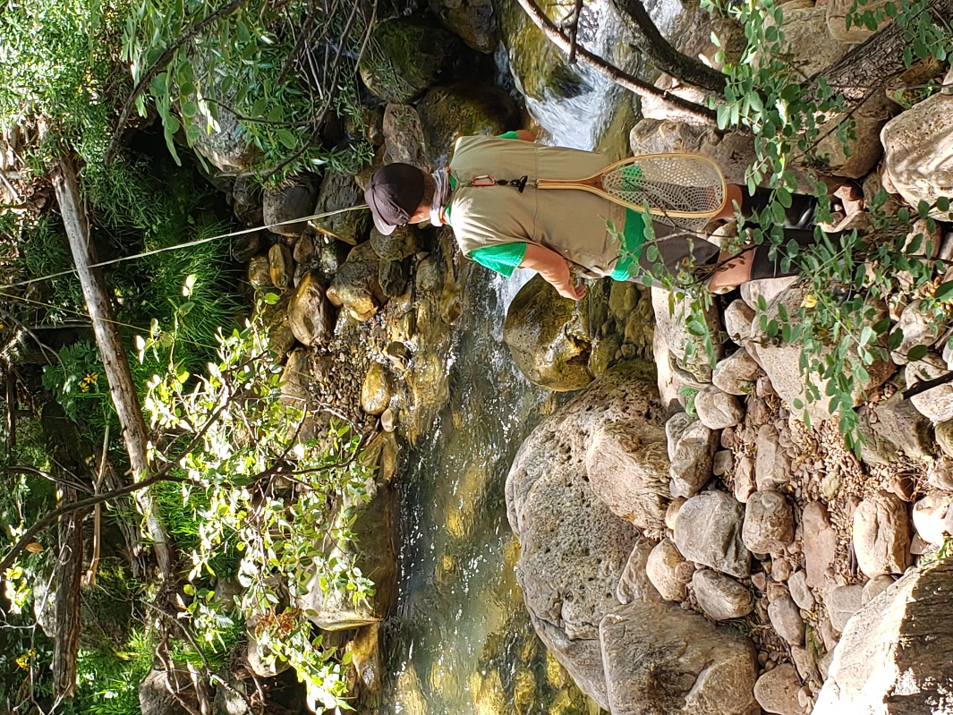
Owen Strogen using downstream technique

PFC / GTTU CONSERVATION ACTION REPORT
From Joe Miller

Local Rim Country Fisheries:

Stream Surveys: Arizona Game and Fish has just conducted a Stream Survey on Horton Creek, tributary to the Tonto. Preliminary volunteer report was Nice, sizable wild browns! Tonto Creek survey scheduling is flexible based on water turbidity, but will be very soon.

Hatcheries:

AZGFD is working diligently to Modernize, upgrade and even expand their Hatchery Operations and Facilities in Arizona, in order to better provide both Improved Recreational Fishing opportunities and better Native Trout programs. Let’s all be aware of that, and work with them as opportunities arise. Our Friends in the Mogollon Sporting Association have donated $25,000 to this great cause! HURRAY FOR THEM! We’ll report to all both progress and new opportunities to help right here in the Newsletter. It’s really being done for our Fishing!

Forest and Watershed Restorations:

Rim Country EIS: The DRAFT US Forest Service 4 FRI Rim Country Environmental Statement is being very actively reviewed and “tweaked” by the FS and the 4FRI Stakeholders Group, including AZGFD, US Fish & Wildlife, Trout Unlimited, and others. It will be published in the next few weeks. The Document will cover Stream, Riparian Area, and Watershed restoration across the Mogollon Rim. Many of our streams and lakes. I’ll announce dates and places for the upcoming Public Meetings.

Biomass: An extremely Critical Issue for wide-scale Forest thinning and management across all of Arizona is disposal of the by-product Biomass or slash from thinning operations. It simply must be removed, or high intensity fire risk remains in place. The thinning is critical to watershed, stream, and lakes protection. In July the Arizona Commerce Commission (ACC) turned down promoting Electrical power production from these materials. Major Bad Decision. We’re now re-grouping to seek a new path way to disposal of the biomass, so forest thinning can proceed. Otherwise, More Fires!

US Forest Service Proposed NEPA Process Revisions: The US Forest Service is proposing new guidelines for how they do environmental studies. TU is submitting comments opposing much of the proposed changes. If you’re interested in information about these proposals, please contact Joe Miller at jamiller101@gmail.com.

PFC/GTTU 2019 Survey Results Summary

Jim Strogen

Thanks to everyone that participated in the survey. We plan to use the information that you provided to help us identify speakers for meetings and schedule activities that reflect your interests. We also want to use it as a springboard for conversation for deciding the Club’s plans for the upcoming year during our August 31st meeting at Tiny’s. We’ll have the actual survey results on hand at the meeting for you to view and reference.
One of the nuggets from the survey is that we have several untapped resources within the Club to provide great insights about fishing destinations or fishing strategies at future meetings. There was also interest by many in the various outreach efforts we make as a Club. There is always room for an extra pair of hands in these endeavors, as well as an opportunity to take on some leadership responsibilities if an area is of particular interest to you.
The information in this summary is based on the results from the thirty members who responded. There is still an opportunity for you to participate if you want to complete the survey.
The overall impressions about the Club, meetings, and activities are that folks come to the meetings for the camaraderie and the opportunity to talk with other fly fishers. We want to learn about fishing nearby locations, destinations outside of the area, and tips that others recommend. We appreciate the quality of speakers that we have had at our meetings and like the ways things are going with the Club.
There were some suggestions such as: more group trips or outings, more casting instruction, stream restoration work, and fly tying activities among others that we should discuss as a group at the August meeting to determine activities of greatest interest to the group this year.
Fishing destinations (near and far) that folks have an interest in learning more about were Rim Country and White Mountain lakes and streams. There was also interest in the San Juan River, Lees Ferry, and destinations in other western states and Canada.
There were a number of fishing strategies/techniques that work for folks that would be great to have an opportunity to include in upcoming meetings such as: nymphing, dry droppers, stripping buggers, and downstream swing with soft hackles. Members also indicated an interest in presentations on casting techniques, regional lakes and streams, knots and rigging, and suggested fishing destinations.
Some of the Club ongoing activities that are always in need of more help and leadership are: Trout in the Classroom, Silver Creek car pool excursions, Project Healing Waters, Wildlife Fair Booth, 4FRI, adult fly fishing Introductory classes, kid fishing programs, taking a new Club member fishing, AZGFD conservation projects.
We look forward to seeing you at the August meeting and having a chance to talk more about opportunities for folks to get involved in these activities in the coming year.
Remember to look for Jim and Carolyn Davis’ report with photos from their Pacific Northwest trip and Alaska with Bedsworth and Hinkie. Other colorful reports will be included at September meeting.

